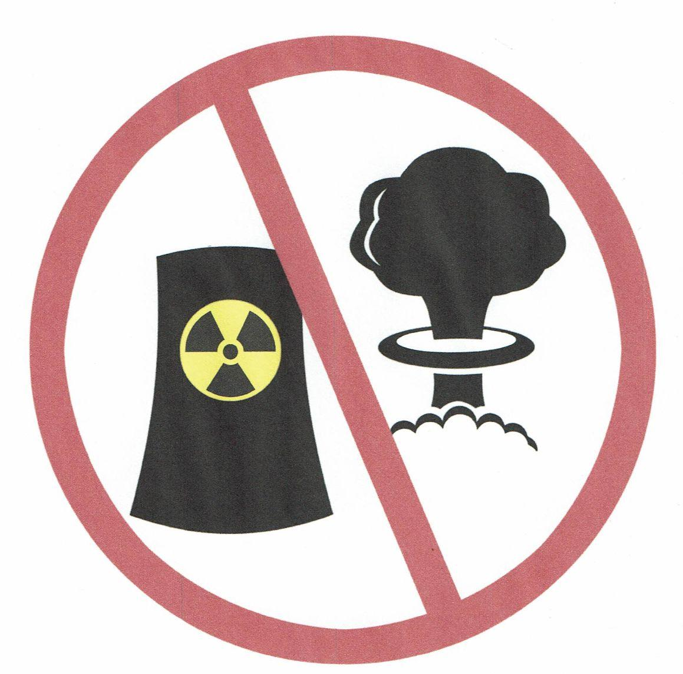
The Ohio Nuclear Free Network
316 North Michigan Street, Suite 520
Toledo, OH 43604

HOW NUCLEAR POWER
WORSENS CLIMATE CHANGE

The nuclear industry has been selling the world a story that nuclear power is a solution to climate change because it does not generate carbon dioxide (CO2), a major greenhouse gas. How this deceptive marketing has become understood as “fact” is astonishing in a free society. Operation of reactors takes plenty of energy even after they are built. The “front end” and “back end” of nuclear power are giant industries that generate almost as much CO2 as natural gas and leave a trail of endlessly dangerous radioactivity all along the way.

☢ Nuclear power has a big carbon footprint. At the front end of nuclear power, carbon energy is used for Uranium: Mining, Milling, Refining and Uranium: Enrichment, Nuclear Fuel Fabrication, Transportation. At the back end, how much energy will be needed to isolate radioactive waste for millennia? Science has no solution for permanently isolating nuclear waste. Reactors and used fuel in pools can melt down if outside electricity is lost for long! The mantra of low/no carbon nuclear has been repeated so often it is taken as fact.

☢ Nuclear power needs big water. Wonder why nuclear reactors sit on oceans, lakes, and rivers? Three reactors at Indian Point used 2.5 billion gallons of water daily – twice New York City’s consumption – and dumped as much heat as in the Hiroshima bomb explosion back into the Hudson River every 2 hours. Heated water causes serious damage to aquatic life, killing millions of fish and untold numbers of macroinvertebrates, aquatic eggs, and larvae. Cooling towers put about half of a reactor’s water intake into the air. Water vapor is a greenhouse gas.

☢ There is no solution to radioactive waste: Throughout the nuclear industry, radioactive contamination of air, land and water occurs. Uranium mine and mill cleanup demands large amounts of fossil fuel. Each year 2,000 metric tons of high-level radioactive waste and twelve million cubic feet of low-level radioactive waste are generated in the U.S. alone. None of this will magically disappear. Vast amounts of energy will be needed to isolate these dangerous wastes for generations to come. Meanwhile, shortcuts are being taken in nuclear waste storage.
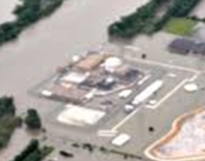
☢ Nuclear power is not suited for warming climates. Nuclear reactors need continuous cool water to remove heat from their cores. Reactors have been forced to shut down during heat waves due to warmth of sea, lake, or river water – just when electricity is being used most. Low water levels during heat and drought have also forced reactors to shut down. Climate change can produce unexpected results, such as disrupting the polar vortex and bringing record cold south. In January 2019, two reactors on the East Coast shut down after screens on their water intakes froze over.
Photo: The Fort Calhoun Nuclear Plant in Nebraska floods in 2011.

☢ Nuclear power is not flexible. Nuclear power is all-or-nothing power. A reactor can’t be geared to produce less power when electricity from renewables (like wind and solar) increases on the grid. When a reactor shuts down due to accident, breakdown, refueling or permanent closure, a large amount of power must be found elsewhere. It’s important to develop renewables NOW to be able to replace electricity when utilities announce reactor closures.

☢ Nuclear power takes too long to deploy. Construction of the 1500 new reactors that the nuclear industry claims are needed to address global warming would mean opening a new reactor once every 2 weeks for the next 60 years. Reactors take 10-15 years to license and build. We need low-carbon energy sources NOW.

☢ New nuclear reactors are unproven. Trying to make nuclear seem new and modern, proposed reactors were first labeled “small” and “modular”. Several would be put together (no longer so small) and thousands would be made (that’s modular). As that did not happen on the ground, new lingo appeared calling the ideas “advanced” and even “ultrasafe”. Old, failed technologies such as molten salt reactors are part of the new “advanced” proposals. Most others are still in the design phase. They are commonly termed PowerPoint reactors because they are unbuilt, untried, and untested. Edwin Lyman, senior staff scientist for the Union of Concerned Scientists, wrote a detailed explanation of the problems with these proposed reactors “Advanced Isn't Always Better”.

☢ Wall Street won’t fund it: The public is being saddled with almost all the costs of design, promotion, and any eventual building of new nuclear reactors. Current reactors could not have been built without public subsidies, including limiting the liability of the industry for accidents and public funding of waste storage and cleanup.

☢ Is the nuclear industry adequately regulated? The American public has put its trust in the Nuclear Regulatory Commission and the Department of Energy to keep the nuclear industry regulated and safe. Failure of regulatory control, when it comes to nuclear power and weapons, can have truly disastrous consequences. Tellingly, the public continues to take legal actions against both agencies, first for lack of public input and second because of public disagreement with regulatory proposals, statutes, and decisions. The public must raise funds for legal challenges, while taxpayers pay for the agencies’ actions and arguments.

☢ Nuclear power produces heat, carbon-14 and tritium. While the nuclear chain reaction produces heat, the thermal output of nuclear waste over millennia is not added to the tally. Reactors release carbon-14 and tritium (radioactive hydrogen) directly into the air and water. C-14 may be our largest exposure to nuclear radioactivity.

☢ Nuclear subsidies rob research on renewables. Nuclear power has been subsidized throughout most of its fuel chain. In 2011 the Union of Concerned Scientists published Nuclear Power, Still Not Viable without Subsidies. This report shows that in some cases subsidies were greater than the value of the electricity produced. Subsidies are supposed to be for new innovations – not for propping up outdated technologies like fossil fuels and nuclear. Nuclear is also a dirty extractive industry – and like coal, oil and gas, nuclear depends on a limited supply of natural resources (uranium) in the ground.

☢ Cost of nuclear is going up, while cost of renewables is going down. Estimates for new reactors are, on average, four times higher than estimates from 10 years ago. Estimates for new reactors are invariably far less than the final cost, with the final cost often doubling and sometimes tripling. Sometimes, as in the cases of the Columbia Generating Station, Cherokee, and Perry, billions were spent while the reactors were never finished.

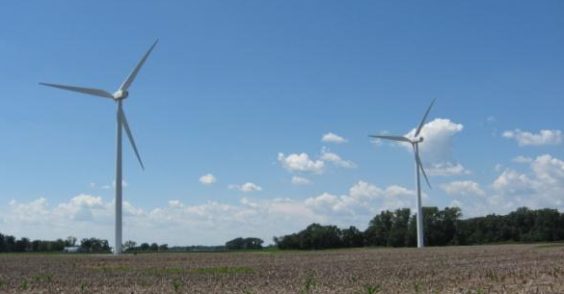
RENEWABLES ARE THE REAL ANSWER!

Mitigating climate disruption demands sound investment in economical, expedient, clean, and most of all, safe technologies. Wind and solar are far cheaper than nuclear. Advances are being made in energy storage. Geothermal energy is being tapped extensively.


As of April, 2022, wind and solar have surpassed the electric output of nuclear in the U.S. Rooftop PV and solar water heaters are very economical and popular. Concentrated solar power arrays are generating electricity directly from the sun’s heat. Distributed, local energy creates local jobs and avoids major power outages.
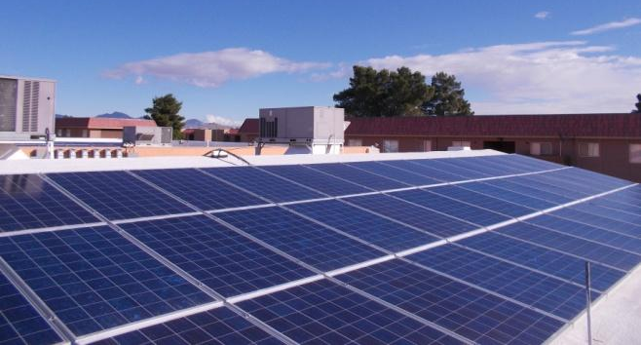
Amory Lovins of the Rocky Mountain Institute and Arjun Makhijani of the Institute for Energy and Environmental Research have written articles and books on how both carbon and nuclear can be replaced nationwide with renewables by 2050. Dr. Makhijani’s book Carbon Free and Nuclear Free: A Roadmap for U.S. Energy Policy can be downloaded from the internet. Phasing out of nuclear power and coal is well underway. Utilities, where not hampered by shortsighted laws, are making the switch to wind and solar. The cheapest “source” of energy has always been efficiency!

 4-20-22: Nuclear Energy Should Not Be Part of the Global Solution to Climate Change by Amory Lovins.
 See the 11-minute Nuclear Energy Information Service video Nuclear Power is not a Climate Solution.
August 2022 Contact: Pat Marida patmarida@outlook.com

